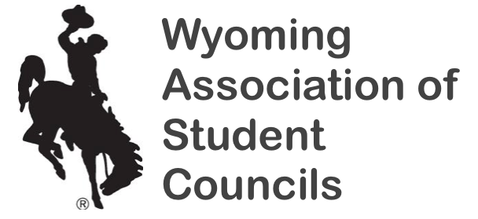
Adviser of the Year Nomination
2021 State Convention

Description:
- Every council has the opportunity to nominate its adviser for this award. Two awards will be presented at the 2021 State Convention:
  - The Jeannie Tinnin Award for advisers with 1 – 5 years of experience as a Student Council adviser, and
  - The Mary Harshberger Adviser of the Year Award for advisers with 6+ years of experience as a Student Council adviser.
- The successful nominee for the Mary Harshberger Adviser of the Year Award will then become Wyoming’s nominee for the national Warren E. Shull Award.
- Each nominated adviser will be introduced at the state convention.
- Nominating an adviser for this award is one of the greatest honors a council can give to its adviser! No matter who is selected, each adviser knows his/her council understands the commitment it takes to be a student council adviser. The honor truly lies in being nominated!
- Due Date = Friday, October 21, 2021
- Email nominations to Patty Mitchelson (pattymitchelson@yahoo.com)

***This nomination may be made with, or without, the adviser’s knowledge.

Nominee’s Name:

Nominee’s School:

Years as a student council adviser:

Local Student Council Activities within the Community – Please list up to 4 of the most impactful activities your council’s adviser has led your council to complete in the past year:

State Student Council Activities
- Please list up to 4 state activities the adviser has participated in since September 2019 (Examples include state convention, school exchanges, NASC attendance, VISION attendance, SLC attendance, Summit attendance, and State Convention attendance)

Local School Involvement
- List up to 4 roles the adviser plays at his or her school. (Examples include department chair, school improvement committee, etc.)

Description of adviser’s involvement within your council
- In written form, please state why you believe your adviser is deserving of these awards.
- Please attach your letter to this nomination form.

Principal/Other Staff Member Recommendation
- Please ask your principal or another staff member within the school to write a letter of recommendation for the award in which you are nominating your adviser for.
- Please attach the letter to this nomination form.

If you submit a partially complete nomination, the nomination will not be considered. Please be sure to submit your nomination no later than October 21, 2021!

