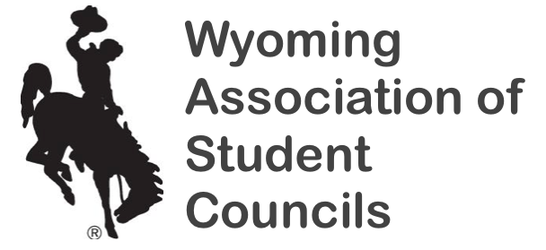

All State Student Council Nomination
2021 State Convention

Description -
- This award honors 15 senior student council members in WASC. Each school can nominate one senior member by a method of the school's choice (Council or Adviser selection). All nominees are recognized at the state convention with a certificate and the 15 members chosen for All State Student Council receive additional recognition. The application can be made with or without the nominee's knowledge.
- Nominations must be received by October 21, 2021. Incomplete applications cannot be considered.
- Email nominations to pattymitchelson@yahoo.com.

Section I: Adviser’s Narrative
- Please explain why this student is deserving of the distinction of All State Student Council. Furthermore, describe the nominee’s involvement and influence within your council. Please comment on the nominee’s work ethic, responsibility, creativity, and leadership.
Section II: School Level Involvement

All State Student Council Point System:

Section II: School Level Involvement
- Student Council positions sought and/or held (elected and appointed) – up to 16 points;
- Committee or project chairperson – up to 12 points;
- Community service project involvement – up to 8 points;
- School service project involvement – up to 8 points;
- School spirit project involvement – up to 8 points;
- Any other major project – up to 8 points.

Section III: State Level Involvement
- Years attending WASC Convention (Freshman – Senior years) – up to 4 points;
- Years attending SLC (Delegate Level I, Delegate Level II, JC) – up to 2 points;
- Candidate for State Office (Sophomore or Junior years) – up to 4 points;
- Candidate for Region Representative (Freshman – Junior years) – up to 2 points;
- Workshop Presenter at State Convention (Freshman – Senior years) – up to 4 points;

2021 All State Student Council Nomination Form

Nominee Name:

School Name:

Section I: Adviser’s Letter of Recommendation
- Please attach a formal letter of recommendation that describes the nominee’s involvement and influence within your council. Please elaborate on the nominee’s work ethic, responsibility, creativity, and leadership. In the event of a tie breaker, the letters of recommendation will be used to break the tie.

Section II: School Level Involvement
- Student Council Positions – Please list up to 4 student council positions the nominee has either attempted to run for or was elected/appointed to from freshman to senior year. Please code the year as FR, SO, JR, SR
- 4 points each

- Committee/Project Chairperson – Please list up to 4 committee or project chairperson positions the nominee has held from their freshman through senior years. Please code the year as FR, SO, JR, SR
- 4 points each

- Community Service Involvement – Please list up to 4 community service projects where the nominee has played a significant role (other than serving as chairperson) during the nominee’s freshman through senior years. Please code the year as FR, SO, JR, SR
- 2 points each

- School Service Projects – Please list up to 4 school service projects where the nominee has played a significant role (other than serving as chairperson) during their freshman through senior years. Please code each year as FR, SO, JR, SR
- 2 points each

- School Spirit Projects – Please list up to 4 school spirit projects where the nominee has played a significant role (other than serving as chairperson) during their freshman through senior years. Please code each year as FR, SO, JR, SR
- 2 points each

- Other Major Projects – Please list any other project in which the nominee has played a significant role (other than serving as committee chairperson) during their freshman through senior years. Please code the year as FR, SO, JR, SR
- 2 points each

Section III: State Level Involvement
- Attendance at WASC State Convention – Please list the years in which the nominee has attended the WASC State Convention. Please code the year as FR, SO, JR, SR
- 2 points per year

- Attendance at WASC Summit Meeting(s) – Please list the years in which the nominee has attended the WASC Summit Meetings. Please code the year as FR, SO, JR, SR
- 2 points per year

- Attendance at Summer Leadership Camp (SLC) – Please list the years in which the nominee was a delegate at SLC (Level I, Level II, and/or JC). Please code the year as FR, SO, JR, SR
- 2 points per year

- Attendance at the VISION Conference – Please list the years in which the nominee has attending the VISION Conference. Please code the year as FR, SO, JR, SR
- 1 point each

- Attendance at the NatStuCo Conference – Please list the years in which the nominee has attending the VISION Conference. Please code the year as FR, SO, JR, SR
- 1 point each

- Candidate for State Office – Please list the year(s) in which the nominee campaigned for a state office. Please code the year as SO or JR
- 2 points per year; maximum of 4 points

- Candidate for Region Representative – Please list the years in which the nominee campaigned for the office of Region Representative. Please code the year as FR, SO, JR
- 1 point per year

- WASC Workshop Presenter – Please list the years in which the nominee has led a workshop at the WASC State Convention. Please code the year as FR, SO, JR, SR
- 1 point per year

